ERC Insight

November 2014

Local Economic Area Innovation Benchmarks – 2002-2010

The UK Innovation Survey provides information on product/service and process innovation as well as the barriers to innovation activity for a relatively large number of UK firms. In this paper we present the first local economic area analysis of this data derived from four surveys covering the 2002-04, 2004-06, 2006-08 and 2008-10 periods. The analysis is possible as locational codes (postcodes) have been matched with innovation data for the first time enabling the innovation profile of individual Local Economic Areas (LEAs) to be captured. The current analysis relates to the 2002-2010 period. New data relating to the more recent 2010-2012 period is due to be released towards the end of 2014. We welcome suggestions for other indicators or analysis which would be useful. Analysis has been undertaken by Stephen Roper, Karen Bonner and Jim Love at ERC.
Contact: Stephen.Roper@wbs.ac.uk

- Introduction
Innovation has been widely associated with economic growth and productivity at the level of the firm, the industry and the nation. In each case innovation relates to the introduction of new products and services, upgrades to business processes and also to changes in strategy, management approaches or marketing. At a local level innovation is also self-reinforcing and capable of producing virtuous circles – firms located in innovative areas are themselves more innovative. Increasing levels of innovation therefore represents a key policy target both at national and local level and the aim here is to provide some local innovation benchmarks.
The UK Innovation Survey used provides information for innovation for a large group of UK manufacturing and service sector establishments (i.e. business units or sites) as well as information on the barriers firms identify to innovation. The central questions considered here are: ‘how innovative are firms within individual Local Economic Areas?’ and ‘Within each area what barriers do firms perceive to innovation?’

- Local Economic Areas’ Innovation performance
Innovation can occur in products or services, business processes and firms’ strategy, management or organisation. We consider here innovation of each type (see Box 1). In terms of product and service innovation, Table 1 – at the end of the document - reports the proportion of innovating firms in each LEA for the four periods 2002-04,2004-06, 2006-08 and 2008-10. Overall, at the English level the proportion of innovating firms has fallen somewhat dropping from 26 per cent in 2002-04 to 21 per cent in 2010. Around this English average performance in the individual LEAs varies significantly, however, from 30 per cent of product/service innovators in the most innovative LEP – South East Midlands – to only 11 per cent in Cumbria (Table 1). Variability in product/service innovation performance between LEAs has, however, remained relatively consistent over the 2002-2010 period.

Box 1: Defining innovation in the UK Innovation Survey

In the UK Innovation Survey innovation is defined as major changes aimed at enhancing your competitive position, your performance, your know-how or your capabilities for future enhancements. These can be new or significantly improved goods, services or processes for making or providing them. It includes spending on innovation activities, for example on machinery and equipment, R&D, training, goods and service design or marketing.
A product or service innovation is the market introduction of a new good or service or a significantly improved good or service with respect to its capabilities, such as quality, user friendliness, software or subsystems.
Process innovation is the use of new or significantly improved methods for the production or supply of goods and services.
Other innovations may relate to new or significantly amended forms of organisation, business structures or practices, aimed at step changes in internal efficiency of effectiveness or in approaching markets and customers. These might be:
- Implementation of a new or significantly changed corporate strategy
- Implementation of advanced management techniques within your enterprise e.g. knowledge management systems, Investors in People
- Implementation of major changes to your organisational structure e.g. introduction of cross-functional teams, outsourcing of major business functions.
- Implementation of changes in marketing concepts or strategies, e.g. packaging or presentational changes to a product to target new markets, new support services to open up new markets.

For individual LEAs the proportion of innovating firms varies somewhat between surveys (see also Figure A1.1) and innovating proportions also vary relative to the average. One way of reflecting this variation is to calculate the 95 per cent confidence intervals which relates to each LEP estimate and these are depicted in Figure 1 for the period 2008-10 (see Annex 1 for derivation). Where the number of respondents in any individual LEP is large – e.g. South East England – estimates are more precise and the confidence interval is narrower. Larger confidence intervals are associated with smaller numbers of respondents in any given LEP. While overall levels of innovative activity suggest a clear gradient in levels of innovative activity the standard errors attached to these estimates are (generally) relatively large and often overlapping. Thus while we can be 95 per cent confident that levels of product/service activity in South East Midlands was greater than that in Thames Valley (and all LEAs to the right of this in Figure 1) we cannot differentiate statistically between levels of product/service innovation in South-East Midlands and, say, Tees Valley.

Figure 1: Proportion of product/service innovators: By LEA 2008-10
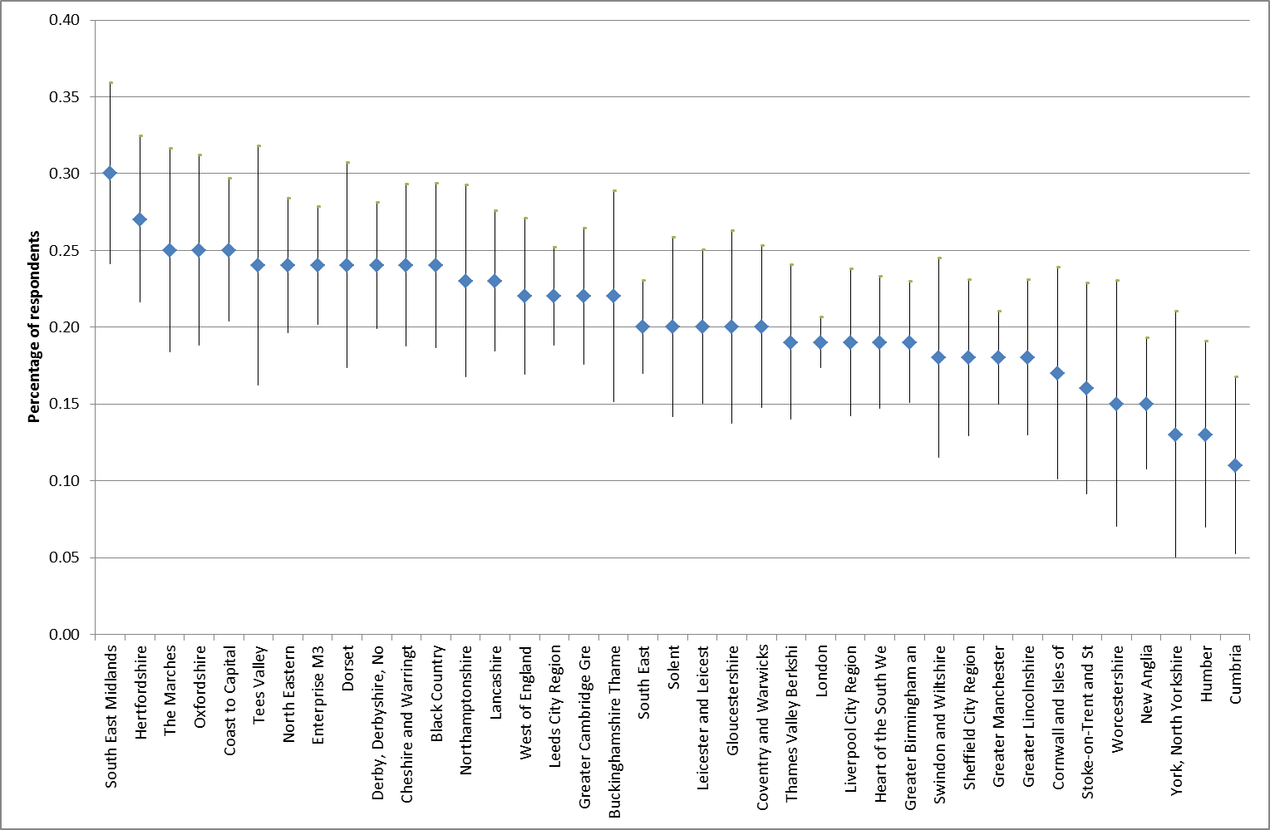
Notes: Responses are weighted. Point estimates and standard deviations depicted.

One alternative approach to examining the development of LEAs innovation activity is to examine whether performance is above or below the national (English) average and to consider how this has changed over the 2002-4 to 2008-10 period. Figure 2 gives this comparison for product/service innovation identifying four groups of LEAs. Nine LEAs including Humber had deteriorated in their position having had above average levels of product/service innovation activity in 2002-04 but falling below average by 2008-10. A further 12 LEAs including South East Midlands had sustained above average levels of product innovation activity in both periods. Another twelve LEAs were below average in terms of innovation in 2002-04 and remained in this position in 2008-10. The final group of six LEAs had strengthening levels of product/service innovation, having been below average in 2002-04 but above average in 2008-10.

Figure 2: Strengthening and weakening product/service innovation performance: 2002-04 to 2008-10
Losing Ground  Humber  Sheffield City Region  London  Leicester and Leicestershire  Cornwall and Isles of Scilly  Liverpool City Region  Coventry and Warwickshire  Thames Valley Berkshire  Worcestershire | Strong Performers  West of England  Derby, Derbyshire, Nottingham and Notts.  North Eastern  Dorset  Northamptonshire  Greater Cambridge & Peterborough  Enterprise M3  Cheshire and Warrington  South East Midlands  Buckinghamshire Thames Valley  Oxfordshire  Hertfordshire
Underperformers  New Anglia  Cumbria  Stoke-on-Trent and Staffordshire  Greater Lincolnshire  Gloucestershire  York, North Yorkshire  Heart of the South West  South East  Greater Manchester  Greater Birmingham and Solihull  Solent  Swindon and Wiltshire | Gaining Ground  Lancashire  Black Country  Leeds City Region  Coast to Capital  Tees Valley  The Marches

The proportion of firms introducing business process innovations is given in Table 2, with LEAs ranked according to the percentage of innovating firms in the 2008-10 period. As with product/service innovation the England-wide proportion of innovating firms has fallen slightly from 16 per cent during 2002-04 to 11 per cent in 2008-10 and again significant variation is evident between the proportion of process innovators in different LEAs. Reassuringly there is also some consistency between those LEAs which appear most innovative in terms of product/service and those where process innovation is most common. South-East Midlands tops both tables.
As with product/service innovation it is possible to estimate 95 per cent confidence intervals around the LEA estimates for process innovation and these are reported in Figure 2 for the 2008-10 period (see also Table 2 at the end of the document). Again these are relatively wide in most cases except where the number of observations in any LEA is large (as in the case of London). The implication is that while we cannot be confident about the measured difference in levels of process activity between South-East Midlands and, say, Oxfordshire we can be 95 per cent confident that levels of process innovation in the South-East Midlands are greater than those in the Heart of the South West and (most) LEALEAs to the right of this in Figure 3.

Figure 3: Proportion of process innovators: By Local Economic Area 2008-10
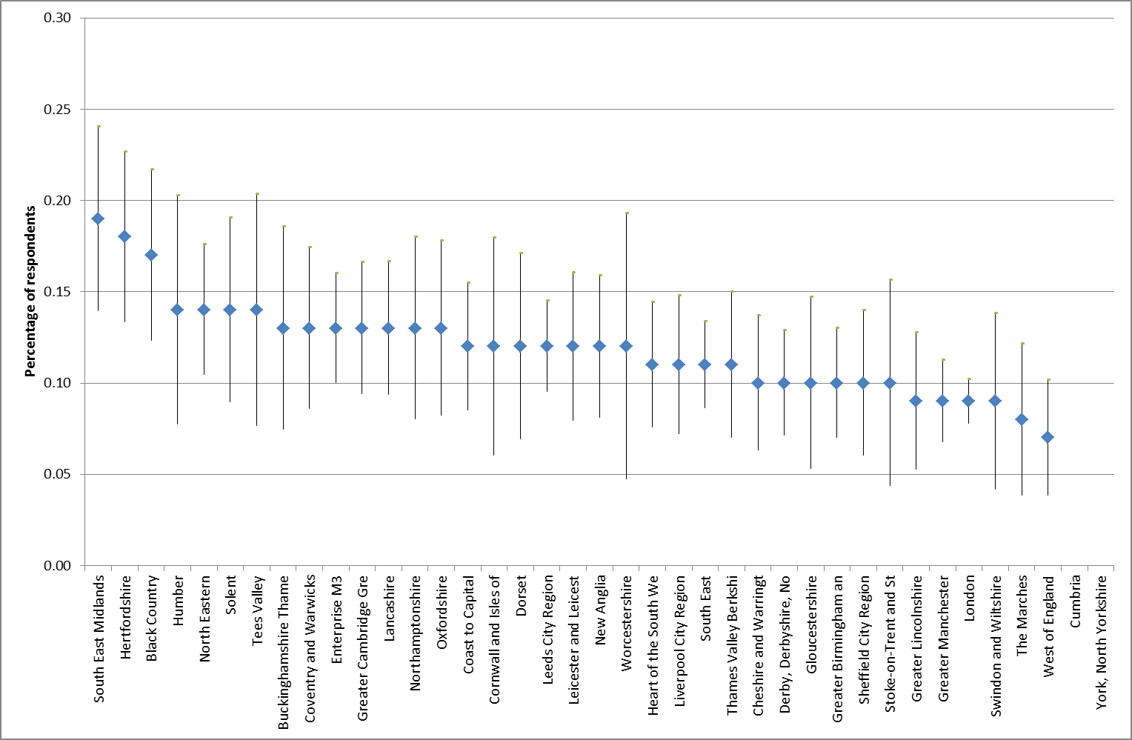
Notes: Responses are weighted. Point estimates and standard deviations depicted. No information is available for Cumbria and York/North Yorks due to small samples.
Organisational innovations prove more common across England than either product or process change with 29 per cent of firms making organisational innovations, 26 per cent of firms reporting that they undertook either organisational or marketing changes, and 13 per cent of firms adopting strategic innovations over the 2008-10 period. Again we observe significant variation in innovation activity across LEAs with some smaller LEAs (for which we have incomplete information) appearing – on average - the most innovative (see Table 3). South-East Midlands again is the most innovative of those LEAs for which we have complete information.

- Barriers to innovation
The UK Innovation Survey identifies ten barriers which firms may face in undertaking innovation, with no distinction being made between barriers to process or product/service change. Overall, the most commonly perceived barrier was the risk of innovation, followed by a series of issues closely related to finance and skills. Lack of information and regulatory barriers are generally less common (Figure 4).

Figure 4: Barriers to innovation in England: 2008-10
 | % firms
Excessive perceived economic risks | 40
Direct innovation costs too high | 39
Cost of finance | 37
Availability of finance | 35
Uncertain demand for innovative goods and services | 29
Market dominated by established businesses | 26
Lack of qualified personnel | 24
UK government and EU regulations (including standards) | 19
Lack of information on markets | 14
Lack of information on technology | 13

Figures 5, 6 and 7 depict the LEA distributions of barriers related to risk, the availability of finance and the availability of skills respectively. In each case we also show related confidence intervals which as before reflect the number of survey observations in each LEA. Here we see a rather different pattern to that observed earlier with firms in a number of the LEAs which had less strong innovation performance reporting significant barriers to innovation. There is however little clear urban-rural or North-South divide in terms of the perceived barriers suggesting perhaps that these are related more strongly to local rather than regional factors.
- Next Steps
Current innovation benchmarks relate to the 2002-2010 period only. New data for 2010-2012 should become available in late 2014 and the benchmarks will then be updated to include this most recent data. We also plan further analysis to explore the relationships between benchmarks at the local level and the relationship between innovation outcomes and local barriers to innovation.
We invite comments or suggestions as to indicators or further analysis which would be useful.

Figure 5: Barriers to innovation – risks of innovation too high
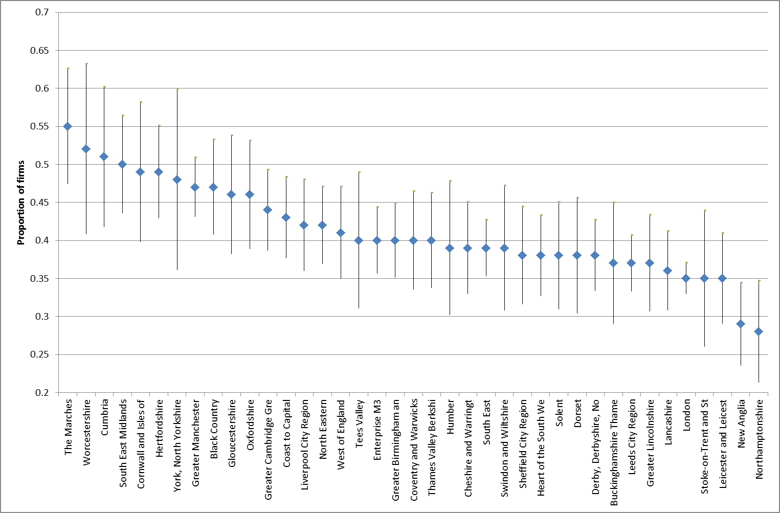
Figure 6: Barriers to innovation – availability of finance
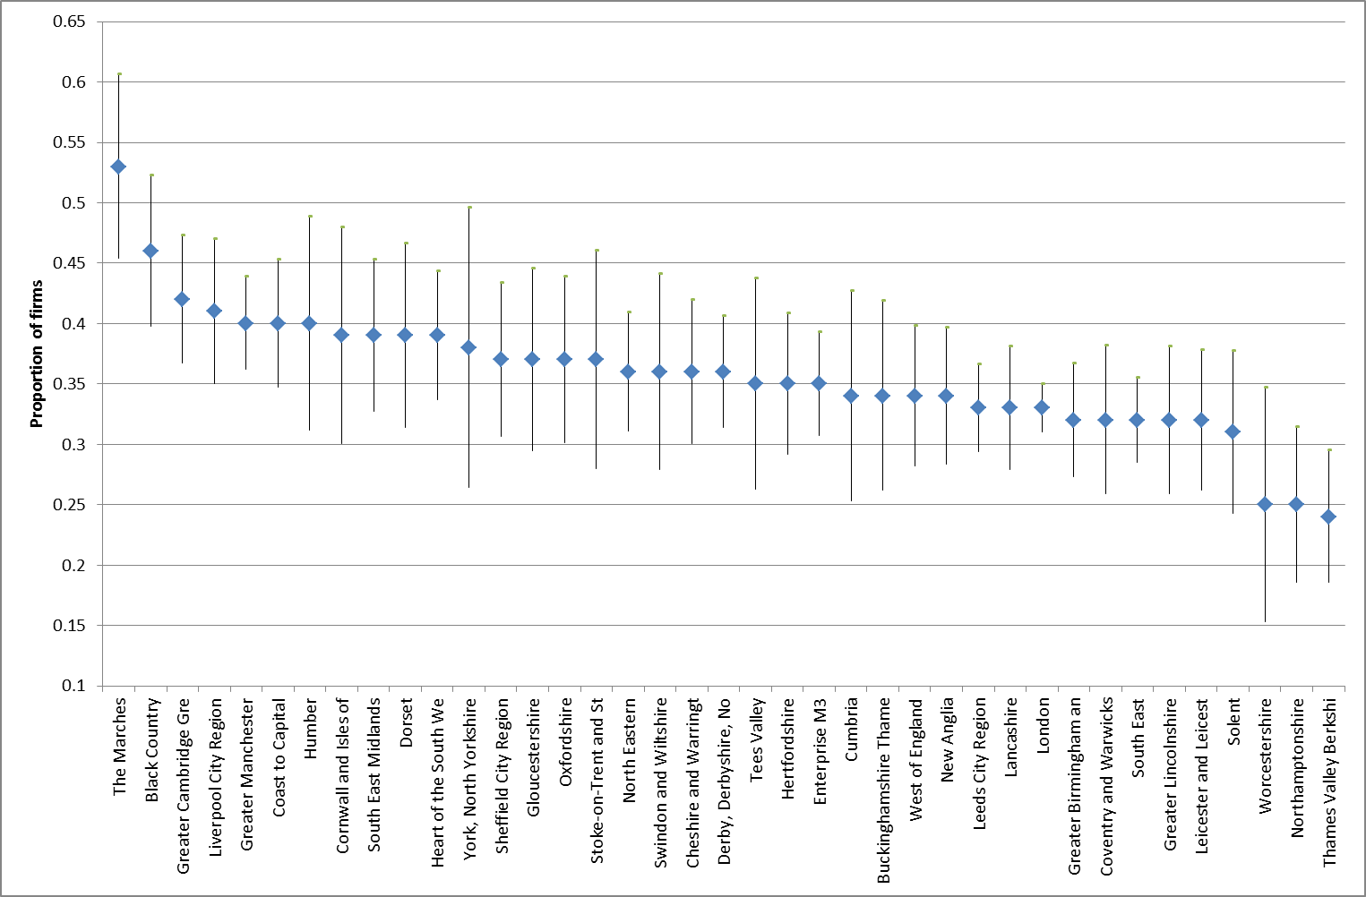

Figure 7: Barriers to innovation – availability of skills
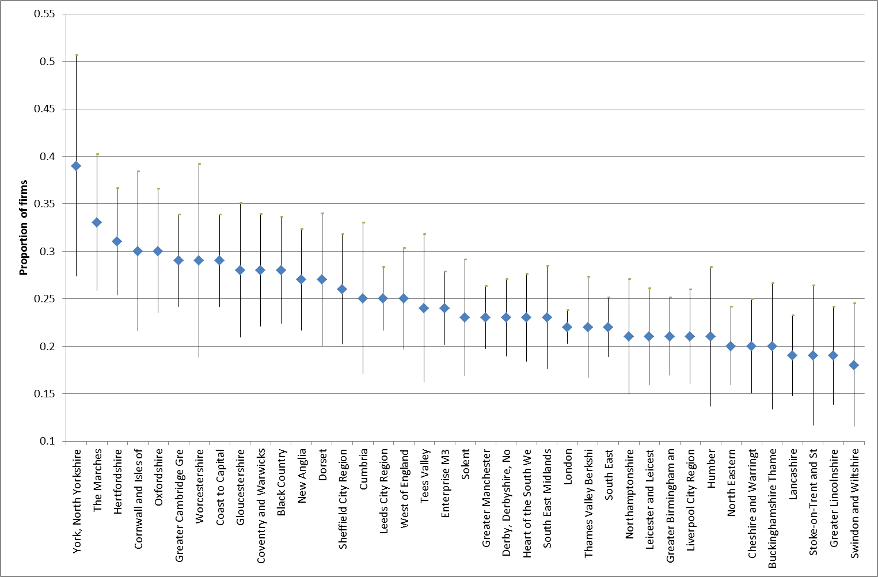

Table 1: Percentage of Firms introducing Product/Service Innovation
 | 2002-04 | 2004-06 | 2006-08 | 2008-10
South East Midlands | 37 | 22 | 29 | 30
Hertfordshire | 30 | 25 | 29 | 27
Coast to Capital | 24 | 21 | 30 | 25
Oxfordshire | 30 | 20 | 30 | 25
The Marches | 25 | 33 | 27 | 25
Black Country | 23 | 21 | 25 | 24
Cheshire and Warrington | 33 | 27 | 27 | 24
Derby, Derbyshire, Nottingham and Nottinghamshire | 26 | 26 | 24 | 24
Dorset | 27 | 29 | 24 | 24
Enterprise M3 | 32 | 29 | 31 | 24
North Eastern | 26 | 23 | 21 | 24
Tees Valley | 25 | 23 | 22 | 24
Lancashire | 22 | 22 | 23 | 23
Northamptonshire | 28 | 26 | 22 | 23
Buckinghamshire Thames Valley | 30 | 27 | 15 | 22
Greater Cambridge, Greater Peterborough | 31 | 29 | 27 | 22
Leeds City Region | 24 | 21 | 24 | 22
West of England | 26 | 21 | 24 | 22
Coventry and Warwickshire. | 30 | 23 | 30 | 20
Gloucestershire | 20 | 20 | 45 | 20
Leicester and Leicestershire | 28 | 22 | 24 | 20
Solent | 24 | 15 | 35 | 20
South East | 23 | 24 | 23 | 20
Greater Birmingham and Solihull | 24 | 22 | 24 | 19
Heart of the South West | 21 | 23 | 21 | 19
Liverpool City Region | 29 | 17 | 23 | 19
London | 26 | 19 | 23 | 19
Thames Valley Berkshire | 32 | 28 | 22 | 19
Greater Lincolnshire | 20 | 19 | 19 | 18
Greater Manchester | 24 | 26 | 23 | 18
Sheffield City Region | 26 | 22 | 28 | 18
Swindon and Wiltshire | 25 | 28 | 23 | 18
Cornwall and the Isles of Scilly | 29 | 16 | 26 | 17
Stoke-on-Trent | 20 | 18 | 18 | 16
New Anglia | 15 | 27 | 19 | 15
Worcestershire | 37 | 24 | * | 15
Humber | 26 | 17 | 18 | 13
York, North Yorkshire | 21 | 21 | 18 | 13
Cumbria | 18 | 27 | * | 11
Total | 26 | 23 | 24 | 21

Notes: Responses are weighted. ‘*’ indicates data supressed due to small number of observations

Table 2: % of Firms introducing Process Innovation
 | 2002-04 | 2004-06 | 2006-08 | 2008-10
South East Midlands | 19 | 14 | 17 | 19
Hertfordshire | 18 | 13 | 15 | 18
Black Country | 16 | 11 | 16 | 17
Humber | 18 | 11 | 12 | 14
North Eastern | 16 | 14 | 14 | 14
Solent | 13 | 8 | 10 | 14
Tees Valley | 17 | 10 | 13 | 14
Buckinghamshire Thames Valley | 17 | * | 18 | 13
Coventry and Warwickshire | 19 | 12 | 13 | 13
Enterprise M3 | 17 | 11 | 18 | 13
Greater Cambridge,Greater Peterborough | 18 | 11 | 14 | 13
Lancashire | 12 | 11 | 11 | 13
Northamptonshire | 17 | 13 | 18 | 13
Oxfordshire | 27 | * | * | 13
Coast to Capital | 14 | 11 | 13 | 12
Cornwall and Isles of Scilly | 19 | 16 | 12 | 12
Dorset | 18 | 10 | 13 | 12
Leeds City Region | 14 | 11 | 14 | 12
Leicester and Leicester | 16 | 13 | 21 | 12
New Anglia | 12 | 10 | 13 | 12
Worcestershire | 22 | * | * | 12
Heart of the South West | 10 | 9 | 14 | 11
Liverpool City Region | 13 | 9 | 9 | 11
South East | 13 | 11 | 15 | 11
Thames Valley Berkshire | 20 | 19 | 18 | 11
Cheshire and Warrington | 23 | 15 | 18 | 10
Derby, Derbyshire, Nottingham and Nottinghamshire | 17 | 12 | 13 | 10
Gloucestershire | 17 | 14 | 13 | 10
Greater Birmingham and Solihull | 16 | 15 | 15 | 10
Sheffield City Region | 17 | 17 | 17 | 10
Stoke-on-Trent and Staffordshire | 11 | 13 | 13 | 10
Greater Lincolnshire | 12 | 8 | * | 9
Greater Manchester | 17 | 12 | 12 | 9
London | 16 | 9 | 17 | 9
Swindon and Wiltshire | 16 | 11 | 13 | 9
The Marches | 20 | 19 | 20 | 8
West of England | 16 | 11 | 16 | 7
Cumbria | * | * | * | *
York, North Yorkshire | * | * | 22 | *
Total | 16 | 12 | 15 | 11
Notes: Responses are weighted. ‘*’ indicates data supressed due to small number of observations

Table 3: Proportion of firms undertaking other types of innovation: 2008-10
 | Organis-  ational | Manag-  erial | Strat-  egic | Mark-  eting | Avg
Cornwall and Isles of Scilly | 36 | 32 | * | 44 | 37
Tees Valley | 30 | 40 | * | * | 35
South East Midlands | 34 | 44 | 19 | 32 | 32
Dorset | 36 | 35 | 23 | 27 | 30
Swindon and Wiltshire | 30 | 29 | 20 | 32 | 28
Liverpool City Region | 28 | 35 | 20 | 24 | 27
Cheshire and Warrington | 29 | 31 | 17 | 29 | 27
Hertfordshire | 32 | 25 | 16 | 33 | 27
Black Country | 31 | 27 | 11 | 36 | 26
Northamptonshire | 28 | 30 | 21 | 26 | 26
Coast to Capital | 28 | 33 | 12 | 30 | 26
Solent | 21 | 29 | 18 | 35 | 26
Bucks Thames Valley | 27 | 34 | 12 | 29 | 26
The Marches | 26 | 36 | 14 | 24 | 25
York, North Yorkshire | * | * | * | 25 | 25
Derby, Derbyshire, Nottingham and Notts. | 28 | 33 | 13 | 25 | 25
Enterprise M3 | 30 | 31 | 13 | 24 | 25
Thames Valley Berkshire | 25 | 28 | 18 | 27 | 25
West of England | 26 | 35 | 11 | 26 | 25
Leicester and Leicestershire | 27 | 35 | 10 | 25 | 24
Oxfordshire | 23 | 25 | 13 | 36 | 24
London | 23 | 30 | 14 | 29 | 24
North Eastern | 29 | 31 | 11 | 24 | 24
Heart of the South West | 25 | 23 | 13 | 33 | 24
South East | 26 | 28 | 12 | 28 | 24
Worcestershire | 25 | 24 | * | 21 | 23
Greater Cambridge Greater Peterborough | 25 | 28 | 8 | 30 | 23
Greater Manchester | 24 | 30 | 12 | 24 | 23
Sheffield City Region | 28 | 28 | 13 | 20 | 22
Lancashire | 23 | 25 | 14 | 26 | 22
Coventry and Warwickshire | 24 | 28 | 13 | 21 | 22
Cumbria | 14 | 25 | * | 24 | 21
Gloucestershire | 22 | 27 | 14 | 21 | 21
Humber | 24 | 20 | * | 18 | 21
Greater Lincolnshire | 22 | 17 | * | 22 | 20
Greater Birmingham and Solihull | 22 | 26 | 11 | 20 | 20
Leeds City Region | 25 | 26 | 9 | 19 | 20
Stoke-on-Trent and Staffordshire | 15 | 17 | * | 20 | 17
New Anglia | 17 | 22 | 7 | 19 | 16
Total | 26 | 29 | 13 | 26 | 24
Notes: Responses are weighted. ‘*’ indicates data supressed due to small number of observations

Annex 1: Methodological notes Innovation indicators by Local Area
The aim of the data analysis undertaken here is to explore what can be learnt about innovation at the level of individual LEAs using data from the UK Innovation Survey (UKIS) waves 4 to 7 covering the periods 2002-04, 2004-06, 2006-08 and 2008-10. Sample sizes and response rates for these surveys were as follows:
- The UKIS 2005 relating to the 2002-04 period covered 28,000 firms and achieved a 58 per cent response rate.
- The UKIS 2007 covering the period 2004-06 surveyed 28,000 companies and received a response rate of 53 per cent or 14,872 valid returns.
- The UKIS 2009 sampled over 28,000 companies and received responses from 14,218 businesses, a response rate of over 50 per cent.
- The UK Innovation Survey 2011 covering the period 2008-10 received responses from 14,342 firms, a response rate of over 50 per cent.
This is secondary analysis – using the survey for a purpose for which it was not originally intended – and the results must therefore be considered in this light. In particular, the UKIS was originally structured to be representative of Government Office regions in England (rather than LEAs). We are therefore extending the use of the data beyond its original design in undertaking this analysis. Having said this, it turns out that (unweighted) observation numbers for most LEAs (except some of the smaller rural LEAs) are reasonable and that results tend to be consistent across waves of the UKIS. Both suggest a degree of confidence in the analysis.
Note also that before release for publication, data have also been checked for ‘disclosure’, i.e. the ability of an interested party to identify any individual business from published data. This results in a small number of results which are unavailable particularly for rural LEAs where the number of observations is relatively small.
Innovation data is taken from various waves of the UK Innovation Survey. Each observation in these datasets has a common reference number which allows it to be linked anonymously to other government surveys. Using these common reference numbers, UKIS observations have been matched (within a secure data environment - the Secure Data Service) with postcode data mainly derived from another data set called the Business Structures Database. This is possible where firms are single plants. In the relatively small number of cases where multi-plants are recorded we match using BERD data. Postcodes are then matched into Local District Authorities and these are matched into LEAs to provide the LEA indicators reported here.
In this annex, and in the graphics in the main text, we make use of the standard 5% confidence interval for a binary outcome variable (a ‘yes’ or ‘no’ survey response). This is calculated as:
$$±1.96√\frac{p(1-p)}{n}$$
Where p is the proportion of respondents saying ‘yes’ in any given LEA and n is the number of observations in any LEA.

Data acknowledgement

The statistical data used here is from the Office of National Statistics (ONS) and is Crown copyright and reproduced with the permission of the controller of HMSO and Queens Printer for Scotland. The use of the ONS statistical data in this work does not imply the endorsement of the ONS in relation to the interpretation or analysis of the statistical data. The analysis upon which this paper is based uses research datasets which may not exactly reproduce National Statistics aggregates.

Figure A1.1: Average product/service innovation performance by wave of UKIS
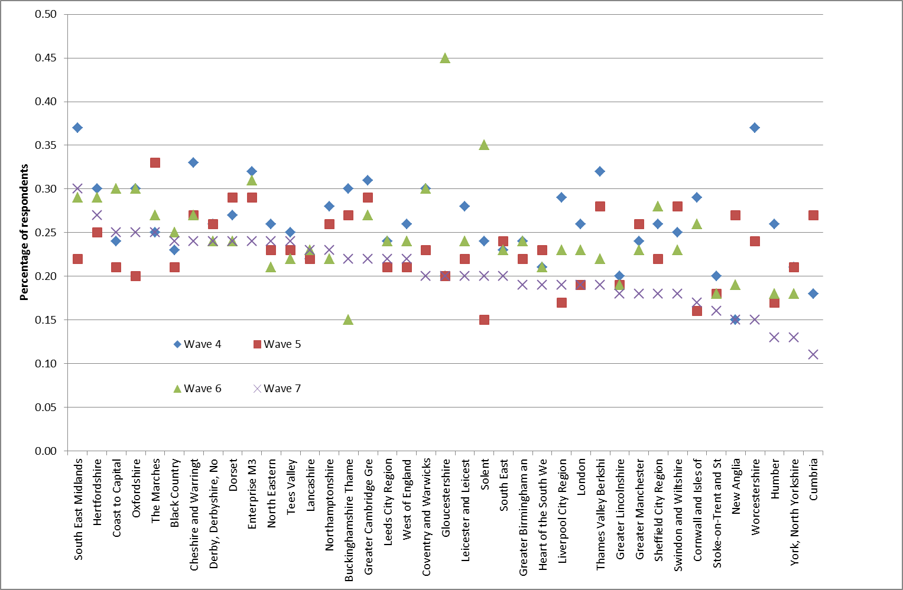
Notes: Responses are weighted.

Figure A1.2: Average process innovation performance by wave of UK
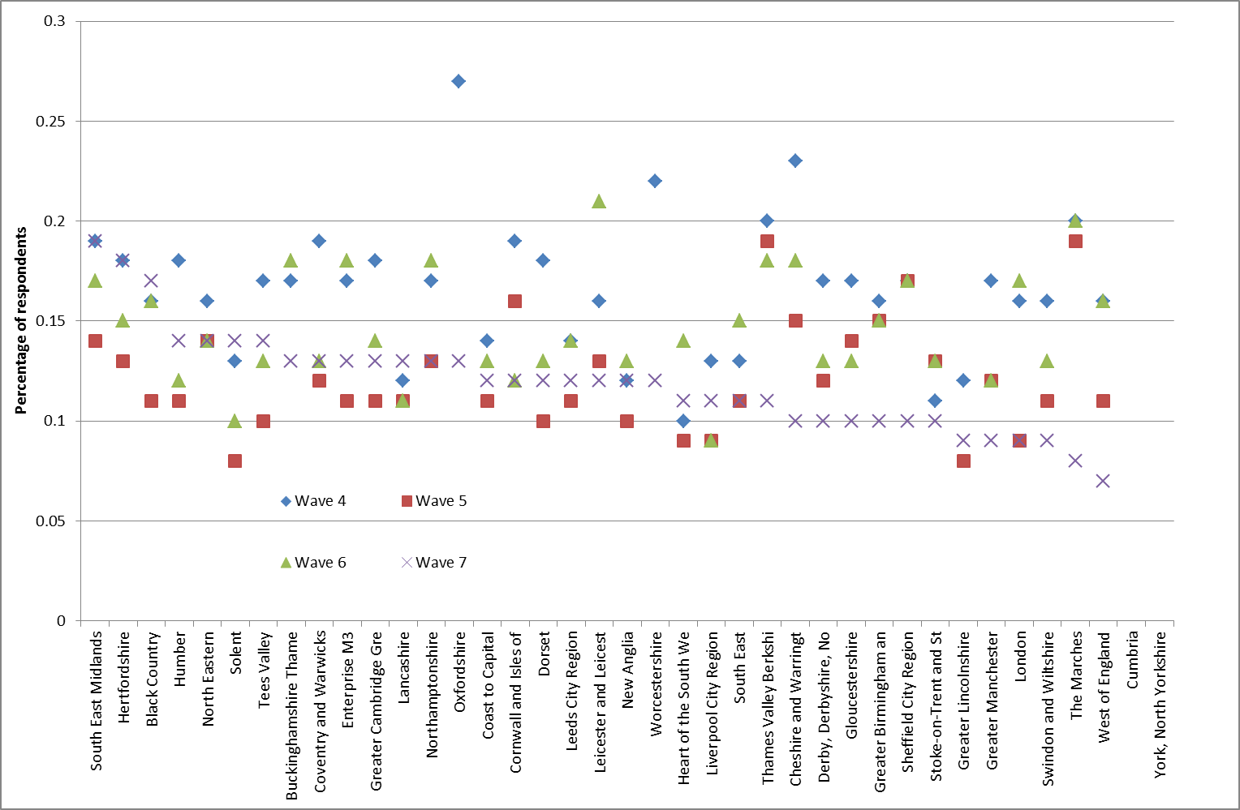
Notes

Crepon, AD ; A Hughes; P Lee and J Mairesse. 1998. "Research, Innovation and Productivity: An Econometric Analysis at the Firm Level." Economics of Innovation and New Technology, 7, 115-58.
Roper, Stephen; Priit Vahter and James H. Love. 2013. "Externalities of Openness in Innovation." Research Policy, 42(9), 1544-54.
Coefficients of variation for the four waves are: 0.184, 0.177, 0.222 and 0.199 respectively.

