ERC Annual Conference Speakers

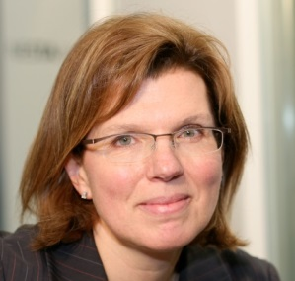

Sherry Coutu chairs Founders4Schools, is the author of ‘The Scale-up Report’ on UK economic growth and serves as a non-executive director on the boards of the London Stock Exchange Group plc, Raspberry Pi, Zoopla plc and Cambridge University (Finance Board).

She was appointed Commander of the Order of the British Empire (CBE) for services to entrepreneurship in the 2013 New Year's Honours List and has been named as an “Ambassador for London” by the Mayor. She is an alumnus of the London School of Economics, Harvard Business School and the University of British Columbia.

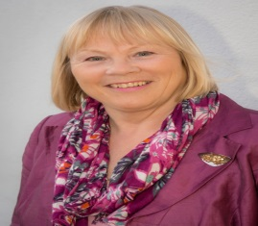

Dr Ann Limb CBE DL is a business leader and social entrepreneur and is Chair of the South East Midlands Local Enterprise Partnership (SEMLEP).After a 25-year career in Further Education. Ann was responsible for the UK government’s flagship digital learning initiative, learndirect and the national e-services programmes Direct Gov and UK online. Moving to the private sector in 2005, Ann has worked as a government adviser both in the UK and overseas. Ann now holds a number of public and private sector non-executive directorships, including at the Homes & Communities Agency. She is also the Chair of a number of organisations including Destination Milton Keynes – the city’s official tourism and visitor information service, and the MK Major Events Board (with overall responsibility for delivering the Rugby World Cup 2015). She founded, and now chairs, a major national educational charity - the Helena Kennedy Foundation, which promotes social inclusion in further and higher education. She is Deputy Lieutenant of the county of Buckinghamshire.