Policy Briefing | 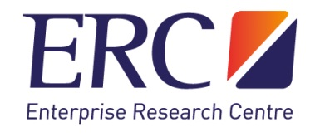
One size does not fit all: A cross-country comparison of policy instruments used to support firm-level innovation and science  Link to full report: http://hdl.handle.net/10344/9543  January 2021  Cross-country, comparative analysis provides a powerful tool for policy evaluation, whilst also offering much potential for policy learning and improvement. In this report we present an analysis of innovation and science policy instruments available to firms in eight countries: Ireland, Germany, the United Kingdom (UK), Belgium, Denmark, Israel, Singapore, and Norway. These countries are all highly active in providing support for firm-level innovation and science, between them allocating in the region of €17 billion in 2017 alone, through a wide variety of policy instruments targeted at firms. Our report is unique in terms of the level of detail provided. Such detail enables a better understanding of the mechanisms through which policy instruments impact firms' innovation and science outcomes. |   Authors    Helena Lenihan Helena.Lenihan@ul.ie    Kevin Mulligan  Kevin.Mulligan@ul.ie  Department of Economics,  Kemmy Business School,  University of Limerick, Ireland
Key findings
Our analysis of the innovation and science policy instruments available to firms across eight countries covering the period 2007-2020 highlights several key observations:
- Countries differ considerably in terms of the policy instruments employed to support firms’ innovation and science activities. Nominally similar policy instruments targeted at firms in each country often differ significantly in terms of their country-specific design features. This makes like-for-like comparisons challenging.
- Since 2012, there has been a rapid growth in the use of R&D tax credits, which have become by far the largest innovation policy instrument in the UK, Ireland, and Belgium. Drawing on the example of these countries, Germany introduced an R&D tax credit scheme for the first time in 2020. However, other countries such as Denmark have not yet followed suit.
- Each country tries to implement the best possible mix of different policy instruments to impact firms' innovation and science outcomes, whilst also trying to find the most effective design for each individual policy instrument in the mix.
- Examining changes over time is crucial to understanding how innovation and science policy instruments lead to firm-level impacts.

Cross-country comparison
Figure 1 demonstrates the different emphasis some countries place on direct funding for firms through R&D grants versus indirectly funding firms through R&D tax credits.

Most publicly available repositories of information do not provide sufficient information to conduct an in-depth cross-country comparison of firm-level supports. For example, although many countries may offer R&D tax credit schemes, some place greater emphasis on Small and Medium-sized Enterprises (SMEs), or firms in specific high technology sectors, while other countries offer across-the-board tax credits available to all firms. This level of detail is crucial when trying to learn policy lessons from other countries’ experiences of using specific policy instruments, in an effort to achieve policy improvements.

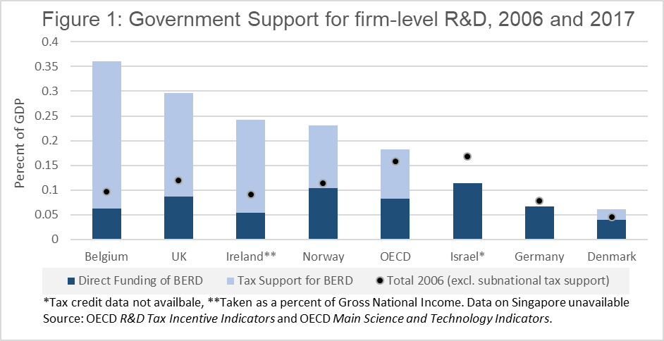

Implications for policy
Countries dedicate significant public funding to support firm-level innovation and science. It is imperative that this investment produces a return for the economy and society. A cross-country comparative analysis offers a powerful tool to foster policy learning and maximise the impact of innovation and science policy instruments. However, our policy report highlights that when it comes to the implementation of public funding for R&D, one size does not fit all.

When examining the science and innovation policy instruments available to firms across different countries, it is crucial to understand the process of policy experimentation, which takes place over a long time period. Policy goals change as the economic and social conditions in each country change over time. This results in alterations to specific policy instruments (e.g. increasing the level of support, or making certain instruments available only to SMEs), as well as the mix of policy instruments on offer to firms (e.g. Germany introducing the R&D tax credit in 2020).

Countries can learn from one another to improve the effectiveness of the innovation and science policy instruments they offer to firms. However, it is crucial that situational differences and policy synergies and overlaps are taken into consideration when comparing policy instruments across countries.

Funding acknowledgement: This publication comes from research supported by Science Foundation Ireland (SFI) under Grant number 17/SPR/5328.

